Secondary Index

Definition
# Source: AI Source: Provided by: [Data Path: Persons Table -> ID Column: 1, Name_En Column: Motasem Essam] -> From: [Chatgpt (GPT‑5 Mini)] on [12/10/2025]
A Secondary Index is an index built on a column (or columns) that is not the primary key.
- It allows faster search and retrieval based on non-unique or non-primary key columns.
- Unlike a primary index, the values in a secondary index may not be unique, so multiple rows can point to the same value.

Key idea:
# Source: AI Source: Provided by: [Data Path: Persons Table -> ID Column: 1, Name_En Column: Motasem Essam] -> From: [Chatgpt (GPT‑5 Mini)] on [12/10/2025]
- Used when you want to search by a column other than the primary key.
- Helps improve query performance without modifying the table structure.

Example: Students Table
# Source: AI Source: Provided by: [Data Path: Persons Table -> ID Column: 1, Name_En Column: Motasem Essam] -> From: [Chatgpt (GPT‑5 Mini)] on [12/10/2025]

ID | Name | Score
1 | Ali | 85
2 | Sara | 90
3 | Omar | 80
4 | Fatima | 88
- Primary key: ID → Primary index exists here
- Secondary index: Could be on Name or Score
Secondary Index on Name (sorted alphabetically):

Name | Row Location(s)
Ali | 1
Fatima | 4
Omar | 3
Sara | 2
- Query: SELECT * FROM Students WHERE Name = 'Sara'
  - Database looks in secondary index → Row 2 → Direct access ✅
Secondary Index on Score (note duplicates allowed):

Score | Row Location(s)
80 | 3
85 | 1
88 | 4
90 | 2
- Query: SELECT * FROM Students WHERE Score = 85
  - Database looks in secondary index → Row 1 → Access record
Row Location
Row location is a pointer or reference that tells the database exactly where a row is stored in the table.
- It is not the data itself — it’s like an “address” to the row.
- Indexes store the key (like Name or ID) → row location so the database can jump directly to the row without scanning the entire table.
- Row location is what makes indexes fast.
- Without row location → database would have to scan all rows.

Key Features of Secondary Index
# Source: AI Source: Provided by: [Data Path: Persons Table -> ID Column: 1, Name_En Column: Motasem Essam] -> From: [Chatgpt (GPT‑5 Mini)] on [12/10/2025]
- Built on non-primary key columns.
- Values may not be unique → multiple rows can match.
- Improves search performance for non-key columns.
- Stored separately from the primary index, usually in B-Tree or Hash structures.

Advantages
# Source: AI Source: Provided by: [Data Path: Persons Table -> ID Column: 1, Name_En Column: Motasem Essam] -> From: [Chatgpt (GPT‑5 Mini)] on [12/10/2025]
- Allows fast retrieval using non-primary key columns
- Improves query performance for searches on frequently used columns
- Supports multiple secondary indexes on different columns
- Helps avoid full table scans for large datasets

Disadvantages
# Source: AI Source: Provided by: [Data Path: Persons Table -> ID Column: 1, Name_En Column: Motasem Essam] -> From: [Chatgpt (GPT‑5 Mini)] on [12/10/2025]
- Requires additional storage for each secondary index
- Slower to update or insert rows because indexes need maintenance
- Values may not be unique → may require extra lookups to fetch multiple rows
- Overhead increases with many secondary indexes, impacting performance

Analogy
# Source: AI Source: Provided by: [Data Path: Persons Table -> ID Column: 1, Name_En Column: Motasem Essam] -> From: [Chatgpt (GPT‑5 Mini)] on [12/10/2025]
- Primary index = roll number list → unique per student
- Secondary index = list of students by grade → multiple students can have the same grade

Summary Table: Primary vs Secondary Index
# Source: AI Source: Provided by: [Data Path: Persons Table -> ID Column: 1, Name_En Column: Motasem Essam] -> From: [Chatgpt (GPT‑5 Mini)] on [12/10/2025]
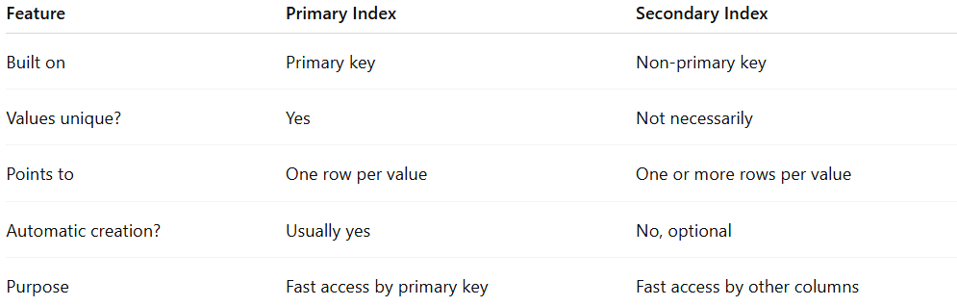
Feature | Primary Index | Secondary Index
Built on | Primary key | Non-primary key
Values unique? | Yes | Not necessarily
Points to | One row per value | One or more rows per value
Automatic creation? | Usually yes | No, optional
Purpose | Fast access by primary key | Fast access by other columns

